**Name:- Abhay Ulhas Kumawat Roll.no:- 178 Class:- FY.BCA Batch:-B6**

**Practical_No: 8 Create a REST API with Node.js ∙ Develop a basic REST API using Node.js that performs UD ( Update, Delete) operations on a simple data set.**

**Step 1. Type this command on Terminal :-**

1. **mkdir node-rest-api**
2. **cd node-rest-api**
3. **npm init -y**

**Step 2.** **Install Express:-**

1. **npm install express**

**Step 3: Create app.js File:- (CODE)**

const express = require('express');

const app = express();

const port = 3000;

// Middleware

app.use(express.json());

// In-memory data

let users = [

{ id: 1, name: 'John Doe', age: 30 },

{ id: 2, name: 'Jane Doe', age: 25 },

{ id: 3, name: 'Jim Brown', age: 35 },

];

// GET - Fetch all users

app.get('/users', (req, res) => {

res.status(200).json(users);

});

// PUT - Update user by ID

app.put('/users/:id', (req, res) => {

const userId = parseInt(req.params.id);

const updatedData = req.body;

let user = users.find(u => u.id === userId);

if (!user) return res.status(404).send({ error: 'User not found' });

user.name = updatedData.name || user.name;

user.age = updatedData.age || user.age;

res.status(200).json(user);

});

// DELETE - Delete user by ID

app.delete('/users/:id', (req, res) => {

const userId = parseInt(req.params.id);

const userIndex = users.findIndex(u => u.id === userId);

if (userIndex === -1) return res.status(404).send({ error: 'User not found' });

const deletedUser = users.splice(userIndex, 1);

res.status(200).json({ message: 'User deleted successfully', deletedUser });

});

// Start Server

app.listen(port, () => {

console.log(`Server running on http://localhost:${port}`);

});

**Step 4: Run the Server:-**

1. **node app.js**

**Output:- Get:-** [**http://localhost:3000/users**](http://localhost:3000/users)

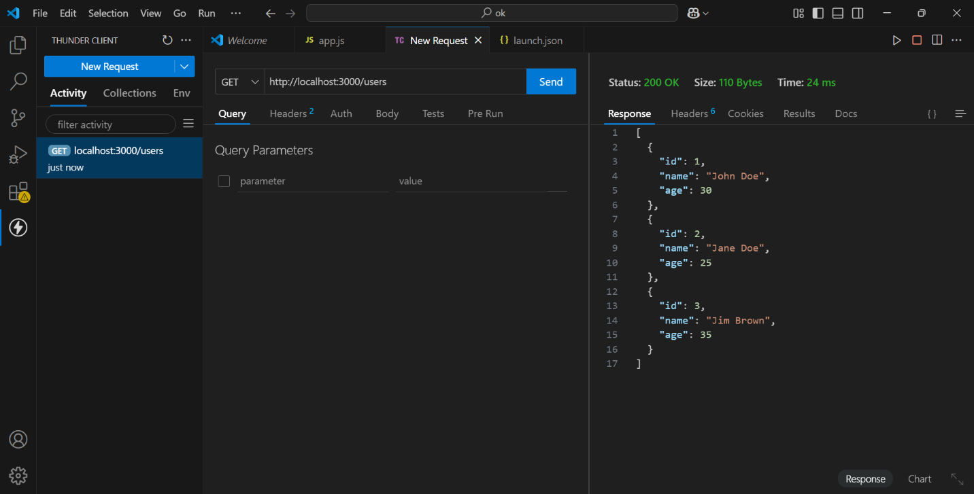

**PUT:-** [**http://localhost:3000/users/1**](http://localhost:3000/users/1)

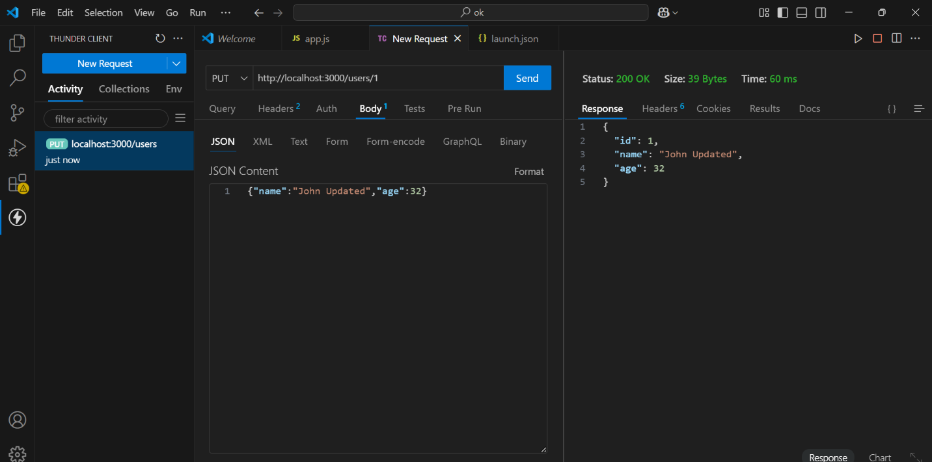

**DELEIT:-** [**http://localhost:3000/users/2**](http://localhost:3000/users/2)

